LUNA SBAHTU

WEB DEVELOPER



# PROFILE

A self-motivated IT professional with huge knowledge and proficiency in Java Script, HTML, CSS, and mobile responsive web development, as well as strong skills and ability in writing clean and efficient code, seeks the position of FrontEnd Web Developer.

# WORK EXPERIENCE

 Aspire Pan Africa Consultancy 2023 - PRESENT

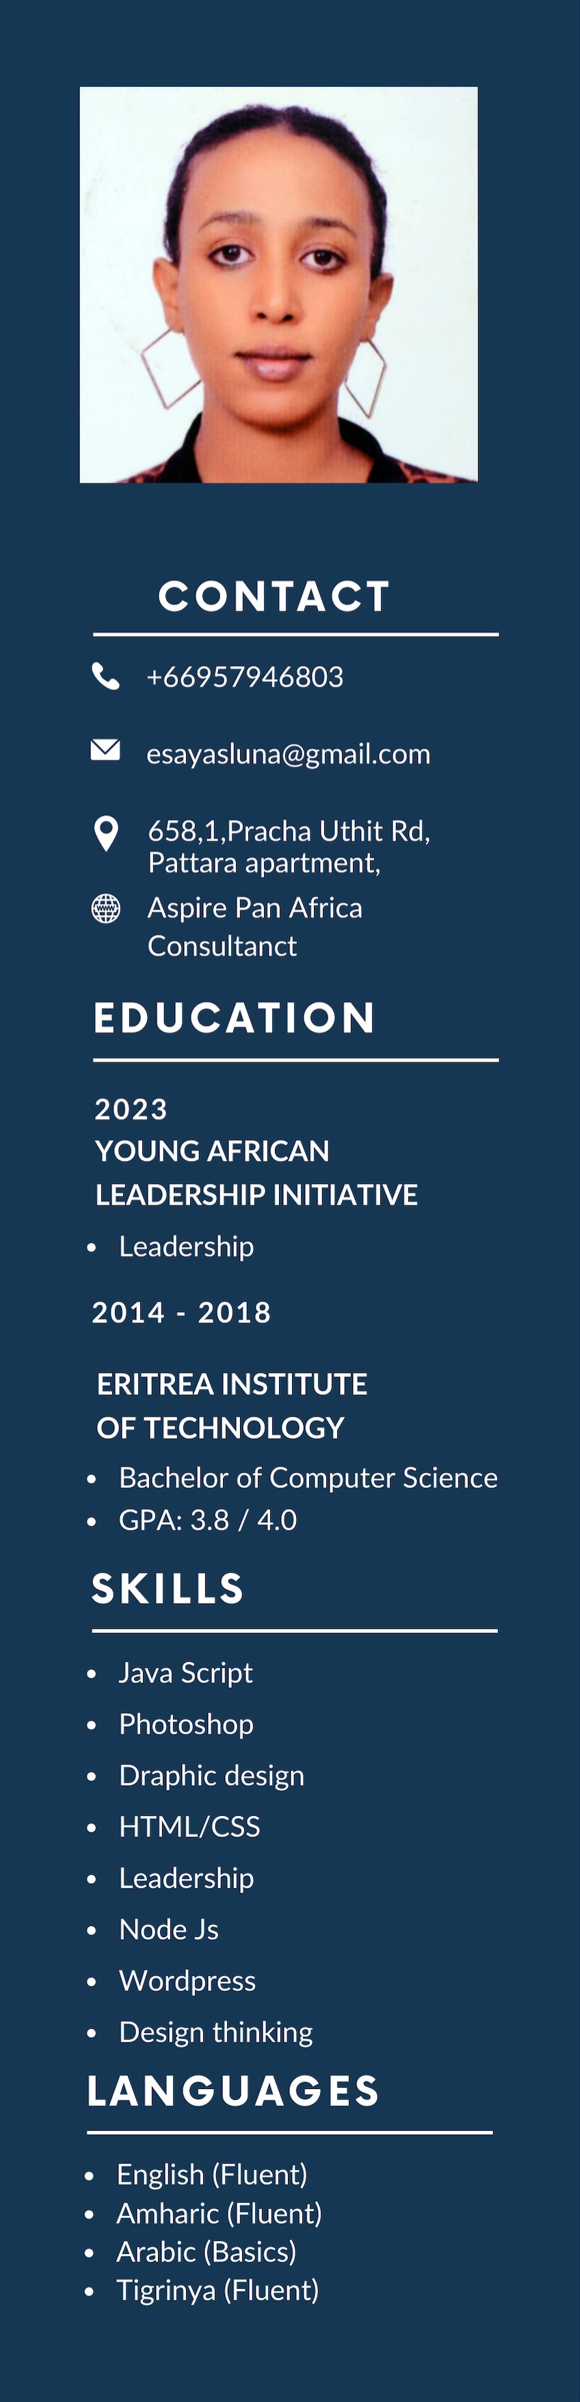IT Assistant and Researcher

* As As an IT Assistant at Aspire Pan Africa, I support IT infrastructure and provide technical assistance, ensuring seamless operation and security for Aspire Pan Africa's business consultancy services.
* Conduct research on business trends and market conditions in Eritrea for Aspire Pan Africa, providing insights to aid strategic decisionmaking for East African clients.

Secondary School 2019- 2022

Teacher

* Developed and delivered dynamic ICT curriculum for high school students, fostering engagement and collaboration. Evaluated student progress and collaborated with peers to ensure effective implementation of educational strategies.

Isola verde Internet Cafe 2009 - 2015

Technical Support Specialist

Handling more complex technical issues that customers or the cafe staff encounter.

Ensuring the internet connection is stable and secure, managing the local network, and setting up new hardware and software.

# REFERENCE

|  |  |
| --- | --- |
| Yacob T. Tesfaldet | Tewolde WoldeKidan (Dr) |
| Faculty of Technology and Environment | Head,Department of Computer Science |
| Phone: +66922377509 | Phone: +2917398166 |
| Email: Yacob.t.tesfaldet@phuket.psu.ac.th | Email : tewolde.w.melake@gmail.com |

